The Laboratory of J’nkor

A D&D Adventure for 5th Edition

Anthony H-W

Troubled Troubadour Tales  STL-MO

The Laboratory of J’nkor

Macintosh HD:Users:narciss:Desktop:000 DND_ASSETS:DnD SHARDS:DnD_shard.eps

A Disturbing Discovery of Dastardly Dirty Deeds

**Introduction**: Once a very successful arcanist, Professor J’nkor lead the world in some of the most brilliant and ground-breaking magical discoveries known across the realm. His inventions and contraptions facilitated life, growth, and brought together many of goodly races towards peace and prosperity. After reaching such fame and fortune, the masterful magic tamer secluded himself in his work chambers to develop another fantastical world-shaping tool.

It has been more than a thousand years since he was last seen and his name is now mere dust in the wind. Even his private library and laboratory have been seemingly lost to time itself.

Or so you’d might think…

A **3-4**-hour adventure for **3rd-4th** level characters.

Optional suggestions included for additional content.

by Anthony H-W



DUNGEONS & DRAGONS, D&D, Wizards of the Coast, Forgotten Realms, the dragon ampersand, *Player’s Handbook, Monster Manual, Dungeon Master’s Guide,* D&D Adventurers League, all other Wizards of the Coast product names, and their respective logos are trademarks of Wizards of the Coast in the USA and other countries. All characters and their distinctive likenesses are property of Wizards of the Coast. This material is protected under the copyright laws of the United States of America. Any reproduction or unauthorized use of the material or artwork contained herein is prohibited without the express written permission of Wizards of the Coast.

©2016 Wizards of the Coast LLC, PO Box 707, Renton, WA 98057-0707, USA. Manufactured by Hasbro SA, Rue Emile-Boéchat 31, 2800 Delémont, CH. Represented by Hasbro Europe, 4 The Square, Stockley Park, Uxbridge, Middlesex, UB11 1ET, UK.

Table of Contents

[The Laboratory of J’nkor 1](#_Toc517975701)

[Table of Contents 2](#_Toc517975702)

[Chapter 1: Background 3](#_Toc517975703)

[Story Summaries 3](#_Toc517975704)

[Ancient History 3](#_Toc517975705)

[Major Adventure 3](#_Toc517975706)

[Chapter 2: Kysmaer Keep 4](#_Toc517975707)

[Stage Information 4](#_Toc517975708)

[Setting Details 4](#_Toc517975709)

[Inquiry 4](#_Toc517975710)

[EVENT 4](#_Toc517975711)

[Key Information 4](#_Toc517975712)

Chapter 1: Background

*“Magic is a truly wondrous thing. It creates… destroys… breathes… lives… grows… but most importantly, it exists all around us. We just have to listen.”*

—Professor J’nkor, Arcanum Maxim

## Story Summaries

This section will cover the basic story summary of this tale. Ancient History, references information unbeknownst to the party that can be gradually revealed as their adventure progresses. Major Adventure, covers the main story beats.

## Ancient History

* This background information is for the **DM**.
* Arch Mage J’nkor Nyfel was a very accomplished magic user and professor of the arcane arts.
* Fellow spellcasters and civilians alike traveled across the land to see his creations and handiwork.
* Students fought over themselves in order to be taken under his wing. Even so far as to create a cult-like following named the “Novices of Nyfel”. Their symbol: an open palm holding a bright violet cracking crystal of energy.
* Eventually, the endless and insatiable appetite for bigger and better magical feats took their toll on the mighty magic bender.
* He secluded himself in his secret chambers in hopes that he may submit to the craved crowds one final treat to soothe the mundane masses.
* His students now exiled from his tutelage found themselves lost and abandoned. Many branched into other prominent arcane organizations. While others aimlessly searched for his whereabouts hopelessly and unsuccessfully.
* Inside his laboratory, J’nkor failed miserably, continuously, and increasingly in magnitude. His inventions were never powerful enough… or efficient enough… or as he called them “meaningful”.
* His grasp on reality faded and in the empty recesses of his mind, dark things grew. Before he was able to realize what was happening, it was far too late.
* J’nkor was no longer himself anymore.
* Meanwhile, a brave young student has finally found a possible link to the Arch Mage’s hidden chambers.
* He’s traced the trail leading to the outskirts of a simple town, only to be blamed for the horrible events occurring around the village.
* This is where we begin our adventure!

## Major Adventure

* This information is the MAIN story plot.
* The adventurers have been conducting various acts of daring do, collecting valuable treasures, and other “accomplishments”.
* There was a collective decision amongst the group to travel back to civilization and rest for a bit before heading out for another great quest. They’ve set their sights on a medium sized village known for their hospitality; in short, it’s a “tourist” town.
* Upon arriving at the small city, they’re caught in the middle of dangerous situation. The local guard is attempting to keep the peace between a rabble of rioting villagers and a lone wounded young mage.
* Once they’ve completed the encounter, they’re informed of strange happenings in the town, that should the adventurers investigate, would lead to all of their ‘vacation’ expenses paid for on behalf of the thankful town leadership.
* They stumble into the makings of a hidden arcane laboratory filled with magical experiments, advanced technology, and a rather tormented version of the Arch Mage J’nkor.
* After resolving the final encounter, the group returns back to town to see that their work in the laboratory has not gone unnoticed.
* Villagers from all over town have come to witness the great and horrible workings (and possible tragic fate) of the Arch Mage.
* The adventurers are rewarded for their efforts and granted their much needed rest.
* (Should he perish) work has already begun on building a memorial for the once great magic user, J’nkor.



Chapter 2: Kysmaer Keep

*“What a lovely town. Bright sunshine and delicate meadows. It’s such a peaceful retreat from the harshness of the world around it. ”*

—Hilda Rory, The Traveling Troubadour

## Stage Information

The party slowly approaches the medium urban city by way of a worn and dusty road. Tired, weary, and all around exhausted they talk amongst themselves about the merriment in the very near future.

## Setting Details

* This information is for the **DM** but can be shared with the adventurers entirely or in segment/pieces.

**The** long trade route is marked with deep scars and groves dug deep into the soil; an old path created by thousands of journeys across the countryside.

**The** inviting city looms around the bend as its’ large stone walls plunge into the sky high above the surrounding fertile farmlands and forests. The city seeming like a bright beacon of civilization to the otherwise timid landscape.

**The** falling sun slowly sinks behind the striking profile of the keep, thus cascading streams of gentle oranges, crimson reds, bright yellows, and dark browns piercing through the tall towers painting the rolling hills like a brilliant portrait of the season.

**Tall** yellow and purple tapestries drape along the battlements emblazoned with a symbol of the local kingdom; a shining ruby-shaded heart circled by a gleaming golden crown.

**Inside** of the massive entry gate are loosely hanging iron chains that shift from large gears that creak and moan from un-use; the portcullis is dark and looming above as it reclusively hides in the shelter of the gate house ceiling.

## Inquiry

Ask the party to discuss either one or both of the following: (other topics may be used, if desired)

* Describe the first activity that they’d wish to partake in once they’ve settled into the city.
* What was their favorite part of their previous adventure? What would they like to do next?

# EVENT

Once inside the city walls, the party finds themselves in the middle of an encounter between three groups.

## Key Information

The adventurers are first introduced to the scene by the DM providing the details based upon a check.

Passive Perception Check

Alternatively, the DM may allow for the adventurers to obtain this information if they successfully pass the DC via an equivalent ACTIVE PERCEPTION check.

|  |  |
| --- | --- |
| **DC** | **Resulting Information** |
| < 10 | The adventurer notices that a large angry crowd has started to gather in the middle of the dirt patched and heavily traversed courtyard. |
| 11+ | They can determine that the crowd is mostly two groupings of city residents; the town guardsmen (referred to as the “Heart Guards”) and the local farmers/townsfolk. They’re currently circling around a smaller humanoid figure in the center. |
| 13+ | They hear shouting from across the entry grounds; several distinct voices stand out: a stern/rigid authoritative declaration, a loud brutish grunt, and a raspy young squeal. |
| 14+ | All three groups appear to be armed and hostile towards each other. The stern voice seems to be echoing from a fully armored and decorated soldier that appears to be standing on a large box. The grunting booms bellow from a portly, bearded, and very furious farmer. |
| 16+ | The humanoid figure, bedraggled in faded/soiled mage robes, scampers around in the center of the dirt courtyard. They’re scraping, snarling, and scratching at anyone that walks too close. The adventurer can sense that their movements are labored and that they’re severely wounded. |
| 20+ | The injured mage’s fingertips gleam and crackle with a purple electrical energy that sparks between swipes. \*\*An arcane user senses that there is a magical presence to the indigo glow. \*\* |

## Encounter Participants

In this encounter, there are three main conflicting groups. The farmers, the guards, the mage.

1. The Farmers: Earle Hemford, a burly country drunkard, has incited a crowd of peasants. (x5)

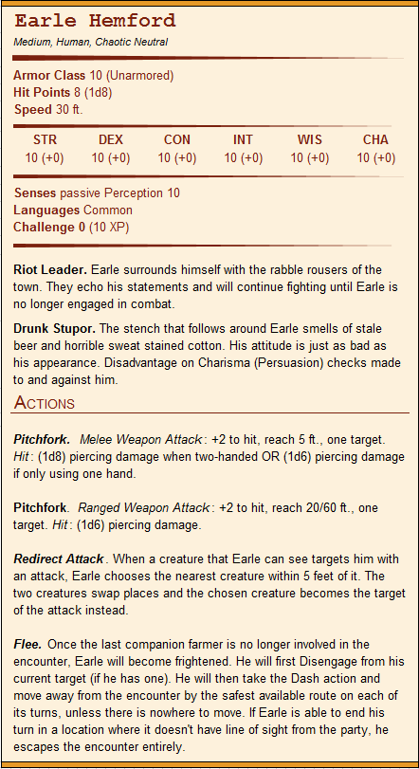

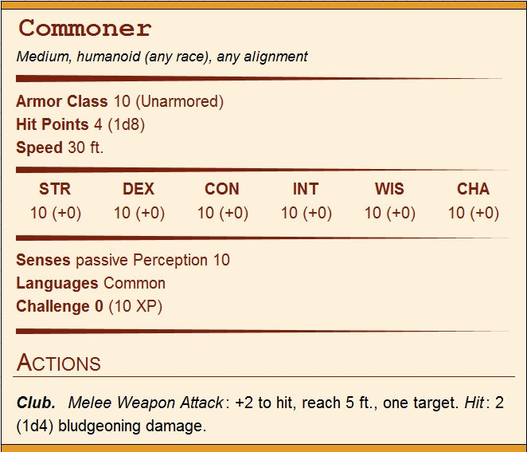

1. The “Heart Guard”